## **OUR TECHNOLOGY**

Clean TeQ’s Clean-iX® continuous ion exchange process provides highly efficient extraction and purification for a range of valuable strategic metals from slurries and solutions. Clean TeQ is focused on applying its proprietary ion exchange processes to the recovery of strategic metals from ores and tailings where the conventional routes are economically marginal or pose an environmental burden that is not sustainable.

Clean-iX® covers the complete spectrum of leach systems (both acid and alkaline):

* Continuous Resin-In-Column (cLX) for clarified leach solutions (<4% solids);
* Continuous Resin-In-Pulp (cRIP) and Resin-in-Leach (cRIL) for slurries (4-50% solids);
* Continuous Elution (U-Column) for metal elution and purification.

Clean-iX® has the following benefits for mining applications:

* Optimised resin inventories, up to 25% less than fixed or batch systems;
* Simple to operate and maintain;
* High turn turn-down ratios to allow for fluctuations in feed grade and operations;

Clean TeQ will own, joint venture or develop assets where the application of our technical approach opens significant values that were previously not able to be captured. Focus will be on ores that are lower grade or polymetallic where the advantages of using a direct concentration process provide the economic driver. Those metals that are of a strategic nature and where future offtake is growing are also on our radar.

## Continuous Resin-In-Column (cLX)

Clean-iX® Continuous Resin-In-Column (cLX) is a continuous counter-current process that extracts metals from clarified leach solutions. The cLX system uses moving packed bed resin columns, where the solution and resin are contacted in counter-current flows. The Clean-iX® cLX system is the most efficient method of direct adsorption available and is suitable for large and small flow rates. cLX operates on solutions with up to 4% solids, minimising pre-filtration requirements.

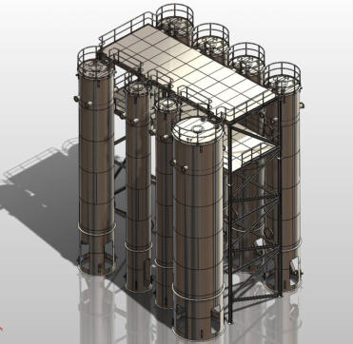

## Continuous Resin-In-Pulp (cRIP)

Clean-iX® Continuous Resin-In-Pulp (cRIP) is a continuous counter current process that directly extracts metals from leached pulps (up to 50% /w solids) and with high resin concentrations (up to 40%v/v). The resin and slurry are mixed directly and moved counter currently in a series of contactors, maximising the efficiency of the process and recovery of target metals. cRIP systems can be integrated with any leaching, elution and purification technology.

In some applications, Continuous Resin-In-Leach (cRIL) gives higher leach recovery rates with a reduction in leaching lixiviants. Here, resin is contacted with slurry during the leaching process for metal extraction.

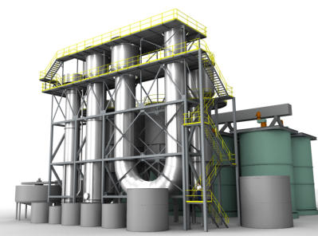

## Continuous Elution

Clean-iX® Elution systems use continuous counter current processing of loaded resins to produce a high purity and concentration metal product solutions. Clean TeQ’s patented U-Column Elution uses a “concentration desorption” process, concentrating the metal in solution as well as scrubbing impurities off the resin. This reduces or eliminates the requirement for downstream purification processes as the product eluate stream contains a high concentration of target metals with minimal impurities. Due to its high efficiency, Clean-iX® Elution systems typically have lower reagent consumptions (up to 33%) compared to batch systems.

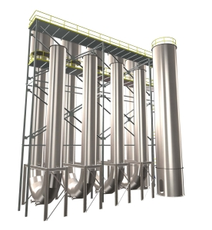

## Metals

Clean-iX® can be used to recover the following metals:

|  |  |  |  |  |
| --- | --- | --- | --- | --- |
| **Precious Metals:**  Gold  Silver | **Platinum Group Metals:**  Platinum  Palladium  Rhodium  Iridium | **Base Metals:**  Copper  Nickel  Cobalt  Zinc | **Rare Earth Elements:**  Light (LRE)  Medium (MRE)  Heavy (HRE) | **Specialty Metals:**  Scandium  Vanadium  Niobium  Tantalum  Uranium  Titanium |

[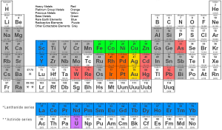](http://www.cleanteq.com/wp-content/uploads/2014/08/periodic_table_of_elements1.bmp)

Metals We Extract