## **Syerston Project Pre-Feasibility Study**

A Pre-Feasibility Study (**PFS**) was completed in October 2016 to assess a large scale project to produce nickel and cobalt sulphate and by-product scandium. The PFS was based on a flow sheet processing 2.5Mtpa of feed in Syerston’s near-surface resource.  The processing plant consists of a high pressure acid leach (HPAL) circuit followed by Clean TeQ’s Resin-In-Pulp (cRIP) for scandium recovery, followed by partial neutralisation and cRIP for nickel and cobalt recovery.

The nickel/cobalt-rich sulphate solution is processed through a small solvent extraction separation and purification step prior to crystallisation to produce separate hydrated nickel sulphate (NiSO4.6H2O) and hydrated cobalt sulphate (CoSO4.7H2O) products.

The scandium-rich solution is processed through a series of selective precipitation stages and a final calcination to produce high-purity scandium oxide (Sc2O3).

The slurry is neutralised by the addition of limestone and sent to a tailings storage facility. The Project mining licence applications incorporate an area close to the Syerston deposit which contains a substantial limestone deposit, this is proposed to be developed as part of the Project. The relatively dry climate of the region means that it is amenable to residue disposal to conventional tailings storage facilities and evaporation ponds.

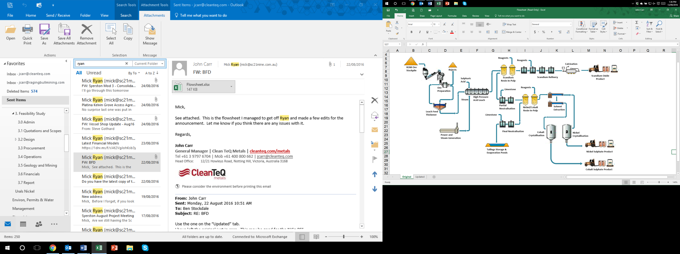

PFS Flowsheet

The PFS assessed the economics of a mine with a designed throughput capacity of 2.5Mtpa of ore feed from Syerston’s near-surface resource, over an initial 20-year mine life.

The following table provides a summary of the key parameters used in the evaluation of the Project. All dollar figures quoted herein are A$ unless otherwise indicated and are exclusive of GST:

Syerston Project Summary Table – Base Case

|  |  |  |  |
| --- | --- | --- | --- |
| Parameter | | | Assumption / Output |
| Processing Plant Throughput | | | **2.5Mtpa 1** |
| Initial Life of Mine | | | **20 years** |
| Autoclave Feed Grade 2 (Year 3-20 average) | | *Nickel* | **0.80%** |
| *Cobalt* | | | **0.14%** |
| Production (Years 3-20 average) | *Nickel sulphate* | | **85,135tpa** |
| *Cobalt sulphate* | | | **15,343tpa** |
| Production (Years 3-20 average) | *Contained nickel* | | **18,730tpa** |
| *Contained cobalt* | | | **3,222tpa** |
| Recovery (Years 3-20 average) | *Nickel* | | **93.5%** |
| *Cobalt* | | | **92.7%** |
| Nickel price assumption 3 | | | **US$7.50/lb** |
| Cobalt price assumption 3 | | | **US$12.00/lb** |
| Exchange Rate | | | **A$/US$ 0.75** |
| Total Capital Cost 4 |  | | **US$680M (A$912M)** |
| C1 Cash Cost (Year 3-20 average) 5 | *before Co credits* | | **US$2.95/lb Ni** |
|  | *after Co credits* | | **US$0.90/lb Ni** |
| Net Present Value (NPV8) – post tax6 | | | **US$891M** |
| Internal Rate of Return (IRR) – post tax | | | **25%** |

*1 Designed processing throughput rate following a 24-month commissioning and ramp up period.*

*2 Includes pit selection, dilution and mining factors applied*

*3 Based on bank/broker long-term consensus market pricing for metal content only. Does not account for or include sulphate product premiums that are typically paid in the market to produce battery-grade nickel and cobalt sulphate.*

*4 Includes a US$62M (A$83M) contingency on capital costs*

*5 C1 cash cost excludes potential by-product revenue from scandium oxide sales and royalties*

*6 Post tax, 8% discount, 100% equity, real terms*

The economic factors determined as part of the PFS were used by Inmett Projects to estimate Proved and Probable Ore Reserves for the Project (for full details see the ASX announcement of 5 October 2016). The table below details the Syerston Nickel and Cobalt Proved and Probable Ore Reserves.

Syerston Nickel and Cobalt Ore Reserves

|  |  |  |  |
| --- | --- | --- | --- |
| Classification  Category | Tonnage, kt | Ni Grade,  % | Co Grade,  % |
| Proved | 54,930 | 0.71 | 0.10 |
| Probable | 41,263 | 0.58 | 0.10 |
| Total | **96,193** | **0.65** | **0.10** |

*\* Ore Reserve is reported as Autoclave Feed tonnes.*

The large-scale nickel/cobalt resource assessed through the PFS also hosts significant quantities of scandium oxide. Given the scandium market is still developing, the PFS Base Case assumed no scandium revenue. However, scandium oxide sales provide a significant increase in the project economics and therefore scandium recovery will be integrated into the larger flow sheet for the Bankable Feasibility Study.

A Bankable Feasibility Study for the project is currently underway and expected to be completed in Q4, 2017.

### Project Infrastructure

One of Syerston’s competitive advantages is its proximity to existing infrastructure. The Project is near the Moomba-Sydney natural gas pipeline, a rail line within 20 kilometres of Syerston and bitumen roads providing good access to the site. The major centres have excellent infrastructure including transport, airport and rail facilities, all of which are available for project requirements. The Project and associated infrastructure are located within the Lachlan and Parkes Shires and the borefield providing water for the Project are in the Forbes Shire.

### Water Borefields

Water investigations undertaken by Clean TeQ, as well as the previous owners, determined that insufficient water was available in the project area to meet the historical requirement.  The closest viable source of water was the borefield near the Lachlan River, approximately 65km south of the project area. A 3.2GL p.a. water licence is currently held by the company and a borefield has been established for the project. The water licence provides most of Syerston’s water requirements for the 2.5Mtpa operation.

A water pipeline will be constructed for the project, providing water from the borefields in the south to the mine site, as well as the limestone quarry.

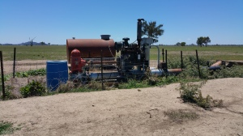

Syerston’s Western Borefield

The Project’s Borefield Environmental Management Plan can be downloaded HERE.

### Resin-In-Pulp for Nickel, Cobalt & Scandium

Between 2004 and 2008, the application of Clean TeQ’s technology for metal recovery from lateritic ores was developed in collaboration with BHP Billiton through an A$8 million investment. Clean TeQ’s continuous resin-in-pulp (cRIP) and elution processes were proven to extract and concentrate nickel and cobalt directly from acidic lateritic pulps at a much lower cost than conventional routes. Uniquely, this allows the purification and production of battery grade nickel and cobalt sulphates direct at the mine site, with no further refining required.

As a part of the current Feasibility Study for the project, Clean TeQ is focusing on securing commitments for nickel and cobalt offtake.  To enable this, Clean TeQ has operated a large-scale continuous pilot plant to process Syerston material to produce nickel and cobalt sulphate samples for potential customers. Additionally, this piloting work will provide process input data for the Feasibility Study.

Development for Clean-iX® for scandium has been carried out over 6 years, with an initial focus on recovery from titanium dioxide waste streams, where the majority of scandium is sourced today. This work culminated in operation of a large-scale scandium recovery pilot plant to a major Japanese titanium dioxide producer in 2015. Subsequently, a large-scale pilot plant campaign was carried out in 2015 on Syerston ore to produce scandium oxide samples for potential customers.

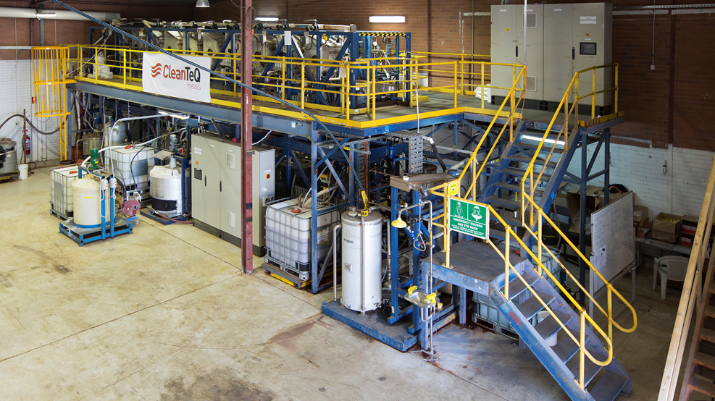

Clean TeQ’s cRIP Pilot Plant in Perth, Australia

### Environment & Permitting

An Environmental Impact Statement (EIS) was prepared in late 2000 by Black Range Minerals as a requirement to apply for Development Consent for the Project.  Potential environmental impacts, impact assessments, mitigation measures and environmental management, rehabilitation and monitoring strategies are documented in the EIS.  The Project was granted Development Consent in May 2001, with a modified Development Consent granted in 2006.

In April 2016 Clean TeQ applied for a modification of the Development Consent to include scandium oxide as a product and to operate an initial smaller scale scandium operation while preserving the approval for a larger nickel/cobalt operation which may be considered in the future. The modification is expected to be approved by the end of Q4, 2016.

The modification application included draft Voluntary Planning Agreements (VPA) which have been agreed with each of the local Shires outlining contributions that Clean TeQ will make to local road upgrades, road maintenance and contributions to a range of community based activities.