## **SYERSTON PROJECT GEOLOGY & RESOURCE**

### ****Geology****

The Syerston project is a typical surficial deposit hosted within a Tertiary age lateritic weathered profile. Metal enhancement of the minerals of economic interest occurred during a secondary process ascribed principally to chemical weathering of the underlying metal rich ultramafic rocks.  During weathering, selective leaching of more soluble elements such as magnesium and silica occurred, leaving a highly iron-enriched residue in base and precious metals.  Further enrichment occurred during mechanical weathering and erosion.

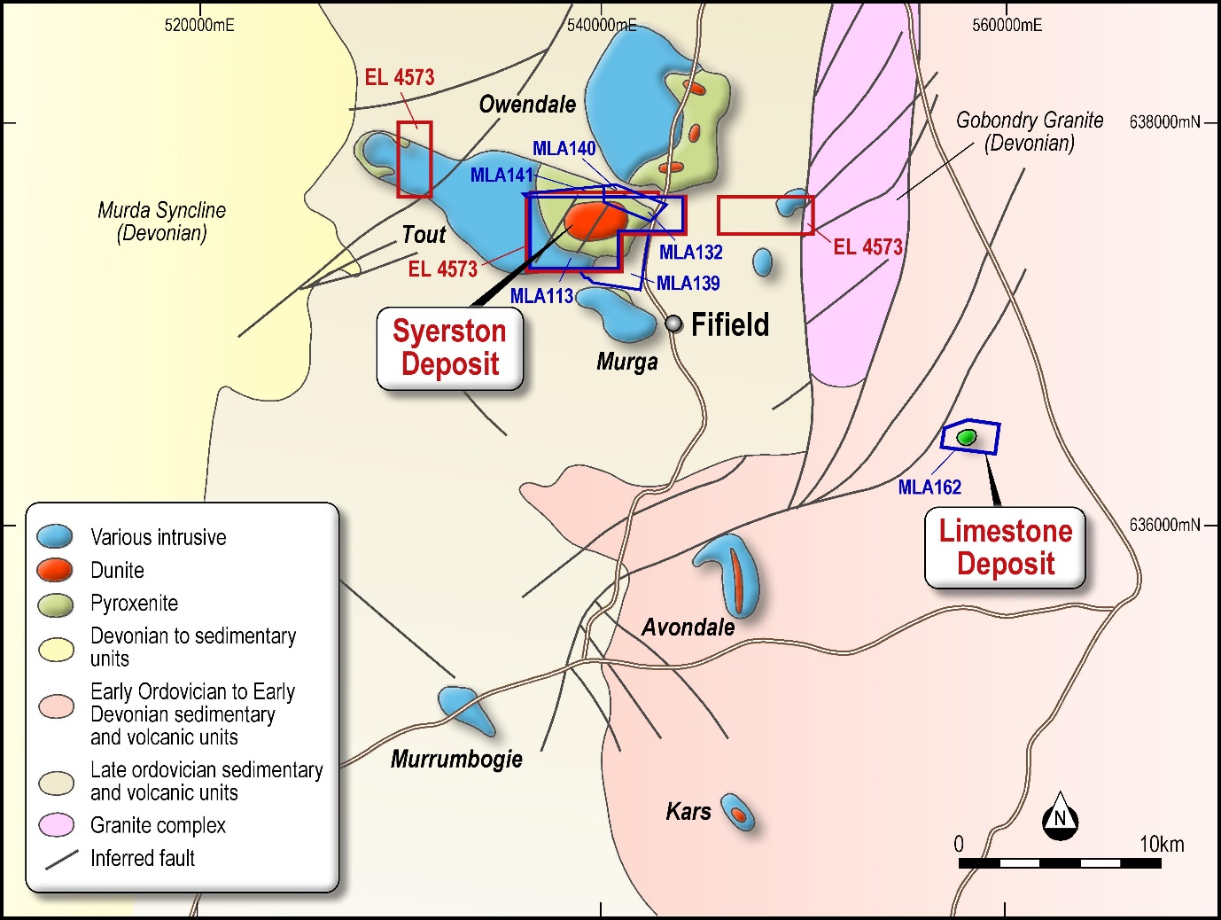

Syerston Project Regional Geology

The Tout Ultramafic Complex is one such intrusive body which underlies the laterite at the Syerston Project.  The complex is concentrically zoned, ultramafic in the core grading to mafic material on the outer edge i.e. igneous rocks composed chiefly of mafic, dark minerals in the core, diminish outwards.  Accelerated preferential weathering over the ultramafic core has resulted in the laterite profile reaching its maximum thickness of 35-40m over the core and thinning out laterally over surrounding less mafic rocks. Nickel and cobalt mineralisation is concentrated on mainly with in the goethite layer over the dunite core, with scandium mineralisation being more concentrated in the pyroxenite surrounding the dunite.

### Nickel/Cobalt Mineral Resource Estimate

The Syerston deposit has been subjected to multiple drilling programmes by five different owners since 1988, with over 1,300 holes drilled over 16 years.

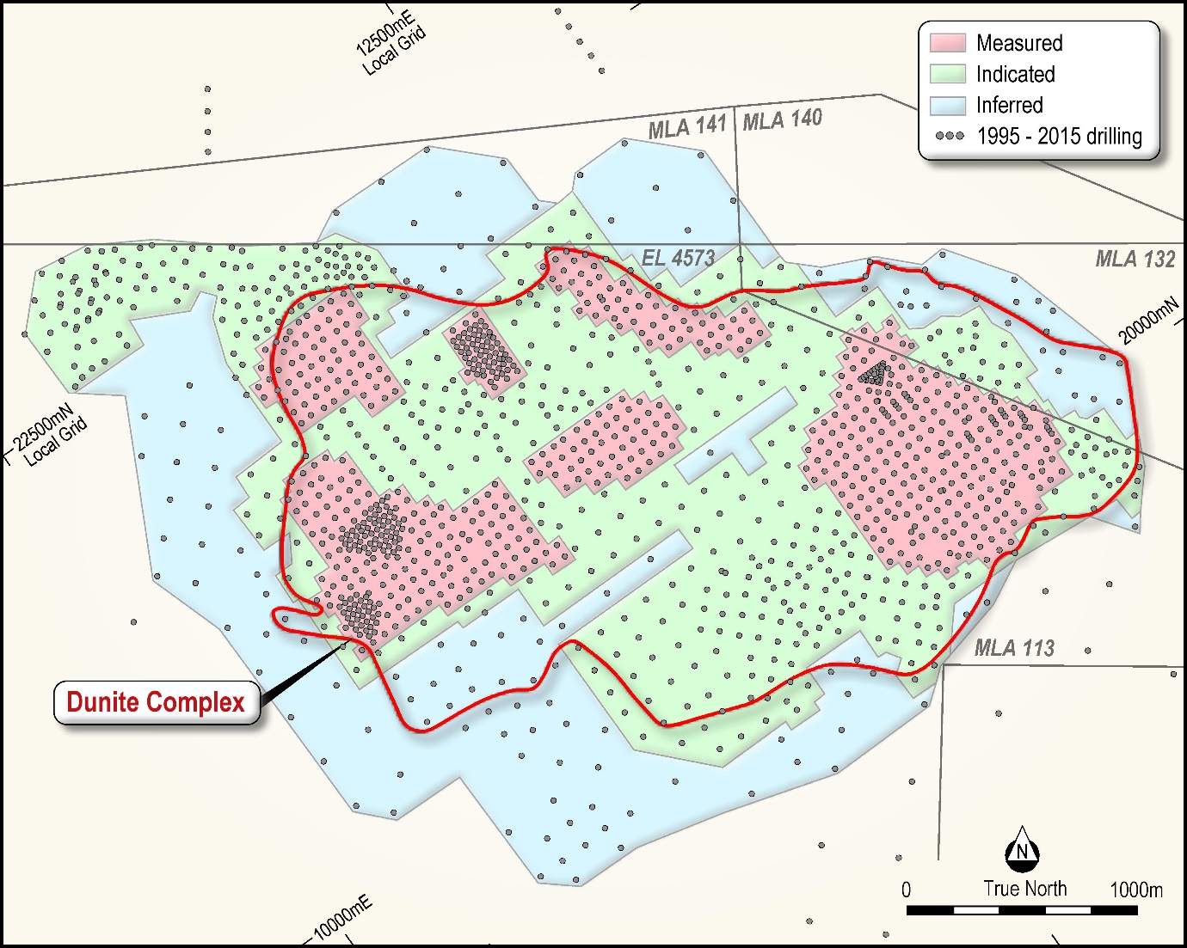

Syerston Nickel and Cobalt Mineral Resource Classification

McDonald Speijers Pty Ltd (**McDonald Speijers**) completed a nickel and cobalt Mineral Resource estimate for the Syerston Project (for full details see the ASX Announcement of 20 September 2016). The resource incorporates revision of the previous nickel and cobalt mineral resource, and has been prepared per the guidelines of the Australasian Code for the Reporting of Exploration Results, Mineral Resources and Ore Reserves (the JORC Code), 2012 Edition. The following table provides a summary of the Mineral Resource Estimate.

Syerston Summary Nickel/Cobalt Mineral Resource Estimate, 0.60%NiEQ Cut-off

|  |  |  |  |  |  |
| --- | --- | --- | --- | --- | --- |
| **Classification**  **Category** | **Tonnage (Mt)** | **Ni Grade**  **%** | **Co Grade**  **%** | **Ni Metal**  **Tonnes** | **Co Metal**  **Tonnes** |
| Measured | 52 | 0.73 | 0.11 | 380,000 | 57,000 |
| Indicated | 49 | 0.58 | 0.10 | 280,000 | 49,000 |
| **Meas + Ind** | **101** | **0.65** | **0.10** | **660,000** | **106,000** |
| Inferred | 8 | 0.54 | 0.10 | 50,000 | 8,000 |
| **Total** | **109** | **0.65** | **0.10** | **700,000** | **114,000** |

*Notes: Any apparent arithmetic discrepancies are due to rounding*

*NiEQ = nickel equivalent*

*Mt = million tonnes*

*NiEQ cut-off was calculated as NiEQ% = Ni% + (Co% X 2.95), based on assumed metal prices of US$4.00/lb Ni, US$12/lb Co, at USD:AUD exchange rate of 0.70. NiEQ was calculated on Ni and Co only, with no consideration for scandium and platinum.*

### Scandium Mineral Resource Estimate

While low grade scandium is associated with the large nickel/cobalt resource, the highest grades are on the periphery. OreWin Pty Ltd (**OreWin**) completed a separate Mineral Resource estimate for the Scandium Resource for Syerston (for full details see the ASX Announcement of 17 March 2016). The following table provides a summary of the Scandium Mineral Resource Estimate.

Syerston Scandium Mineral Resource Estimate

|  |  |  |  |  |  |
| --- | --- | --- | --- | --- | --- |
| **Cut-off** | **Classification**  **Category** | **Tonnage Mt** | **Sc Grade**  **ppm** | **Sc**  **Tonnes** | **Sc2O3**  **Equiv Tonnes\*** |
| **Sc**  **>300ppm** | Measured | 5.8 | 454 | 2,635 | 4,032 |
| Indicated | 15.9 | 420 | 6,697 | 10,247 |
| Inferred | 6.4 | 386 | 2,487 | 3,805 |
| **Total** | **28.2** | **419** | **11,819** | **18,083** |
| **Sc**  **>600ppm** | Measured | 0.6 | 685 | 394 | 603 |
| Indicated | 0.8 | 663 | 545 | 834 |
| Inferred | 0.1 | 630 | 57 | 87 |
| **Total** | **1.5** | **670** | **996** | **1,524** |

*\* Sc tonnage multiplied by 1.53 to convert to Sc2O3*.

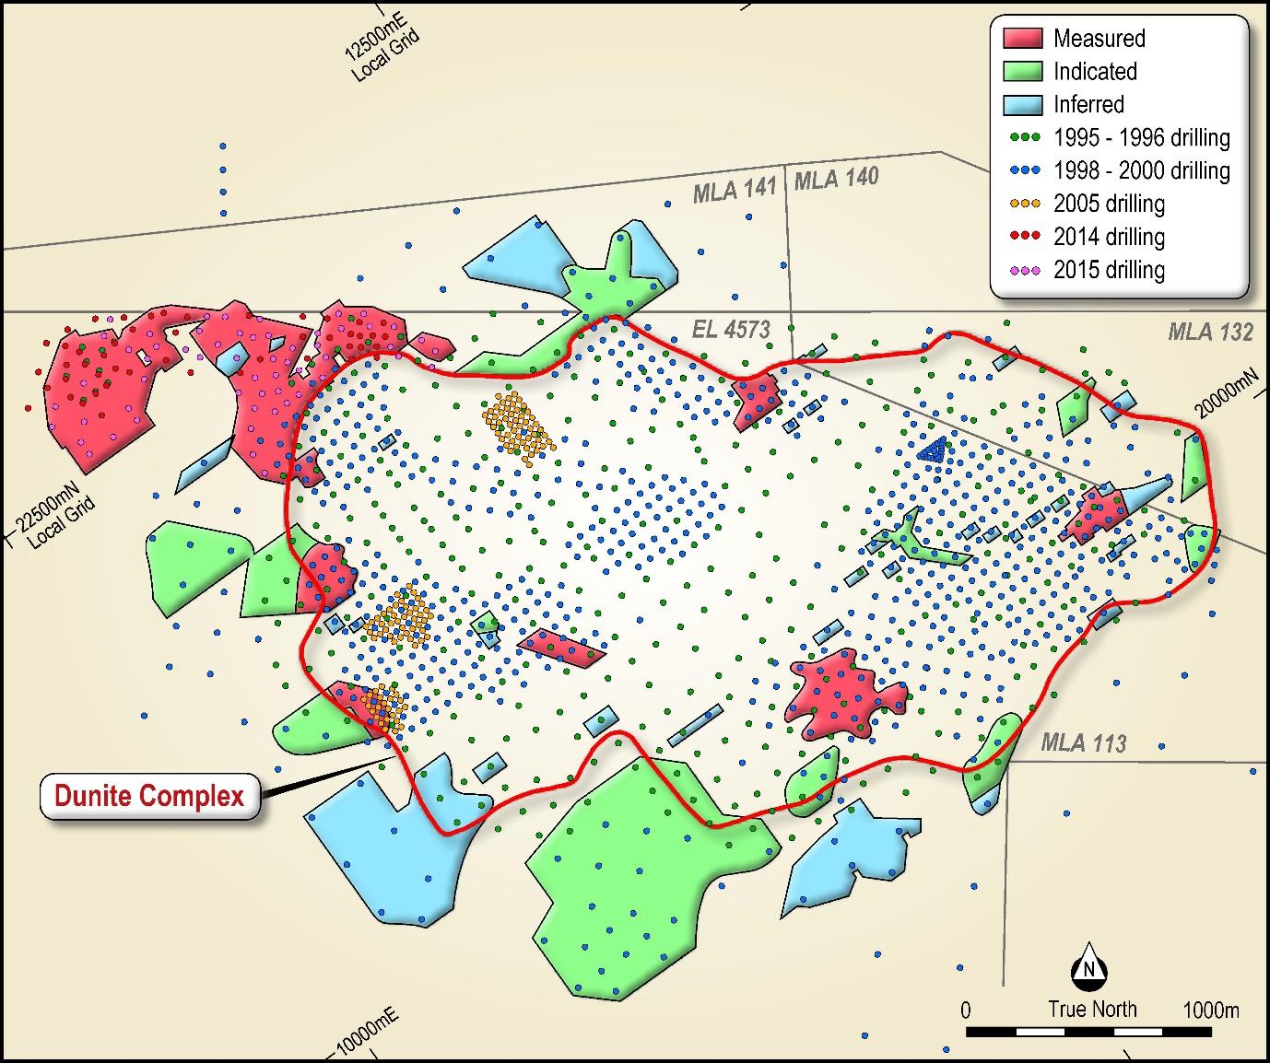

Syerston Scandium Mineral Resource Classification