**Syerston Project Overview**

Clean TeQ is developing its world-class Syerston Nickel Cobalt Scandium Project, utilising its Clean-iX® technology. The Syerston deposit is one of the largest and highest grade undeveloped nickel and cobalt resources outside Africa and contains the world’s largest and highest grade scandium resource.

A Bankable Feasibility Study (**BFS**) is underway for the Syerston Project, due for completion in 2017, Q4. The BFS will assess the economics of a large scale project producing battery grade nickel and cobalt sulphates - key raw materials required by the lithium ion battery sector - and by-product scandium oxide.

**Location**

The Syerston deposit is situated in central New South Wales, approximately 350km WNW of Sydney. The project is well supported by major centres, with the mining communities of Parkes, Dubbo and Condobolin, all located within 100km of the project area.

[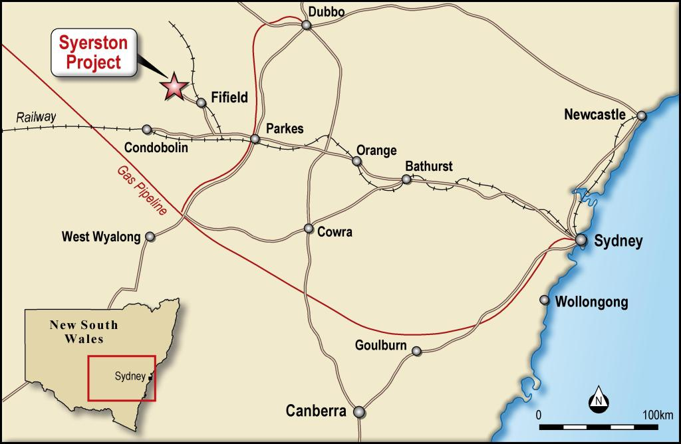](http://www.cleanteq.com/wp-content/uploads/2014/08/Syerston-Project-Map.jpg)

Syerston Project Location

The major centres have excellent infrastructure, which includes transport, airport and rail facilities, which are available for Project requirements. In addition, the mining industry within the region is well understood and supported by the major centres. Several large operating mines exist within the region which includes the NorthParkes, Peak Hill, Browns Creek, Lake Cowal and Cadia mines.

### ****Mineral Titles & Landholding****

Clean TeQ owns 100% of EL 4573, overlapping MLA’s, as well as freehold land ownership over most of the project area. EL 4573 was granted on 17 August 1993 and will be required to be renewed on 15 August 2018.  Clean TeQ also owns a limestone deposit to the south-east of the mine site.

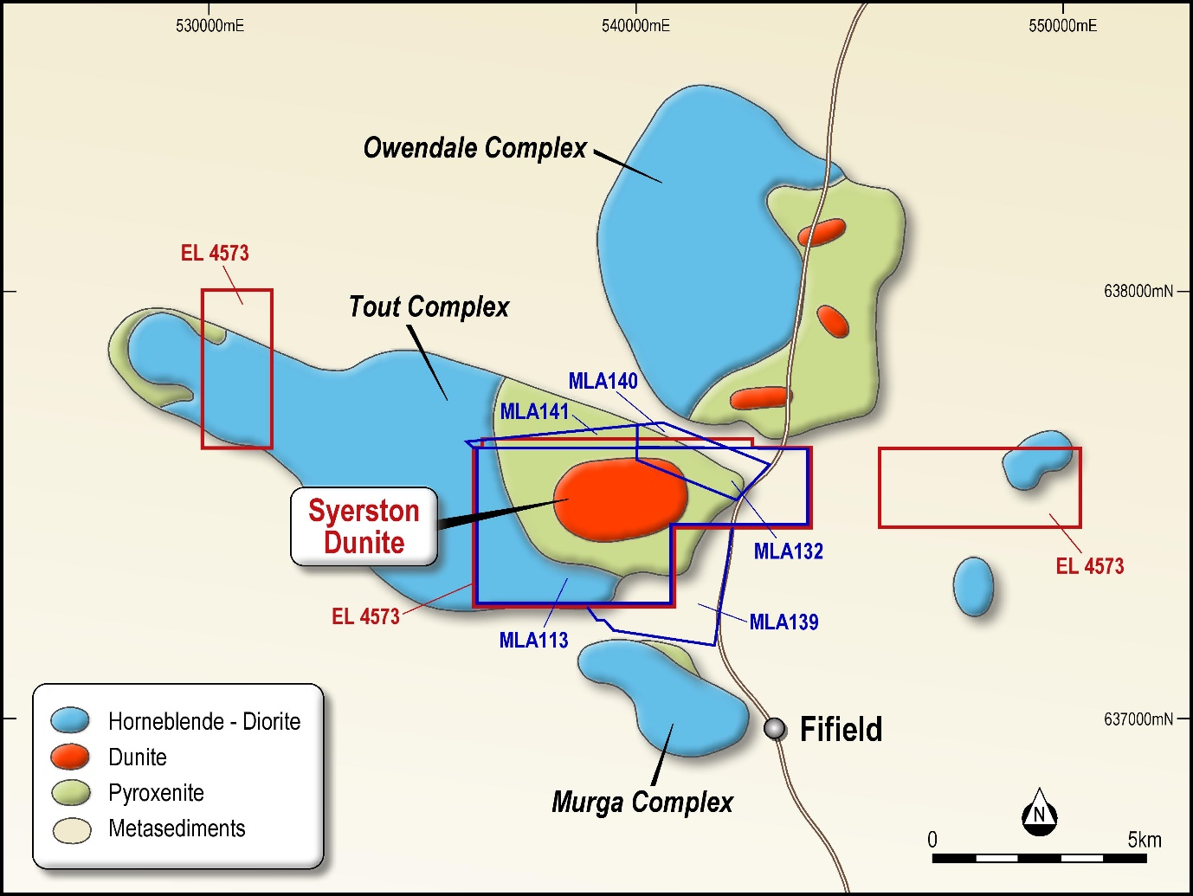

Syerston Tenement Overview

### ****Project History****

The Fifield district remains the location of Australia’s only historic source of platinum production, with approximately 20,000 ounces of the metal being extracted from deep leads between 1887 and the mid-1960s. Despite promising indications of platinum mineralisation, few companies have succeeded in identifying economic grades of PGM mineralisation.

In 2000, SNC-Lavalin completed a Feasibility Study for Black Range Minerals Limited, the then owner of the project, for a nickel laterite operation. The project obtained development approval from the New South Wales government in 2001.

In 2004, Ivanhoe Mines acquired the project from Black Range Minerals and in 2005 Ivanhoe completed a revised Feasibility Study with SNC-Lavalin. In May 2006, the development consent was triggered on the project.  The project did not proceed to full development due to the prevailing base metal prices at the time.

Clean TeQ acquired the project from Ivanhoe Mines Ltd (TSX:IVN) in 2014. Since that time, Clean TeQ has completed a Feasibility Study for a small scale scandium-only project designed to produce 50tpa scandium oxide from some very high scandium grade areas on the periphery of the main laterite deposit. Clean TeQ also completed a Pre-Feasibility Study for a large scale nickel/cobalt/scandium project. The Pre-Feasibility Study revised the estimates of the previous feasibility studies undertaken in 2000 and 2005 and integrated Clean TeQ’s technology into the proposed processing flow sheet to produce battery grade nickel and cobalt sulphates - key raw materials required by the lithium ion battery sector - and by-product scandium oxide. A Bankable Feasibility Study is underway for the nickel/cobalt/scandium project, due for completion in 2017, Q4.