## **Nickel & Cobalt for Lithium Ion Batteries**

Cobalt and nickel are critical raw materials in the production of cathodes for the lithium-ion battery (**LiB**) market. These metals are used in the production of precursor materials, which are converted to cathode active material for use in the batteries.

The battery industry requires nickel and cobalt to be supplied in specific chemical form for production of precursor material. In the case of both cobalt and nickel, this is generally in the form of hydrated metal sulphates (CoSO4.7H2O and NiSO4.6H2O).

The demand for lithium-ion cells is anticipated to grow strongly over the next decade as production of electric vehicles increases and batteries become an important component in utility-scale energy storage systems.

Syerston’s high cobalt grades, combined with Clean TeQ’s proprietary Clean-iX® technology to produce the specific cobalt and nickel sulphates required by lithium-ion cell manufacturers, positions the Company to benefit from strong forecast growth in demand for LiB’s.

The global LiB market has grown at a 20% compound annual growth rate (CAGR) over the last 10 years[1], mainly due to the steady growth in portable electronic devices (laptops, smartphones, etc) and, more recently, the emergence of automotive applications. Forecasts for LiB demand growth vary, but even the most conservative estimates are predicting LiB demand to experience rapid growth over the next 10 years.

Historic and Forecast Global LiB Sales (‘GWh) 5

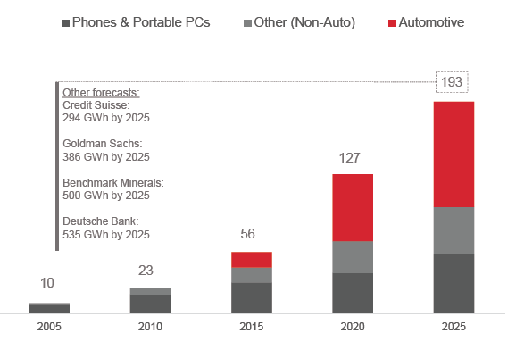

Much of the current acceleration in demand for LiB’s is resulting from their use in electric vehicles. From approximately 0.5 million plug-in hybrid electric vehicles (**PHEV**) and battery electric vehicles (**BEV**) sold in 2015, demand is forecast to grow to 2 million units by 2020 and 6 million units by 2025. As battery costs fall, BEV drivetrains with higher capacity batteries are expected to replace PHEV’s and hybrid electric vehicles (**HEV**), further adding to demand for key raw materials.

Figure 5: Forecast Global x-EV Sales (2014 – 2025) [2]

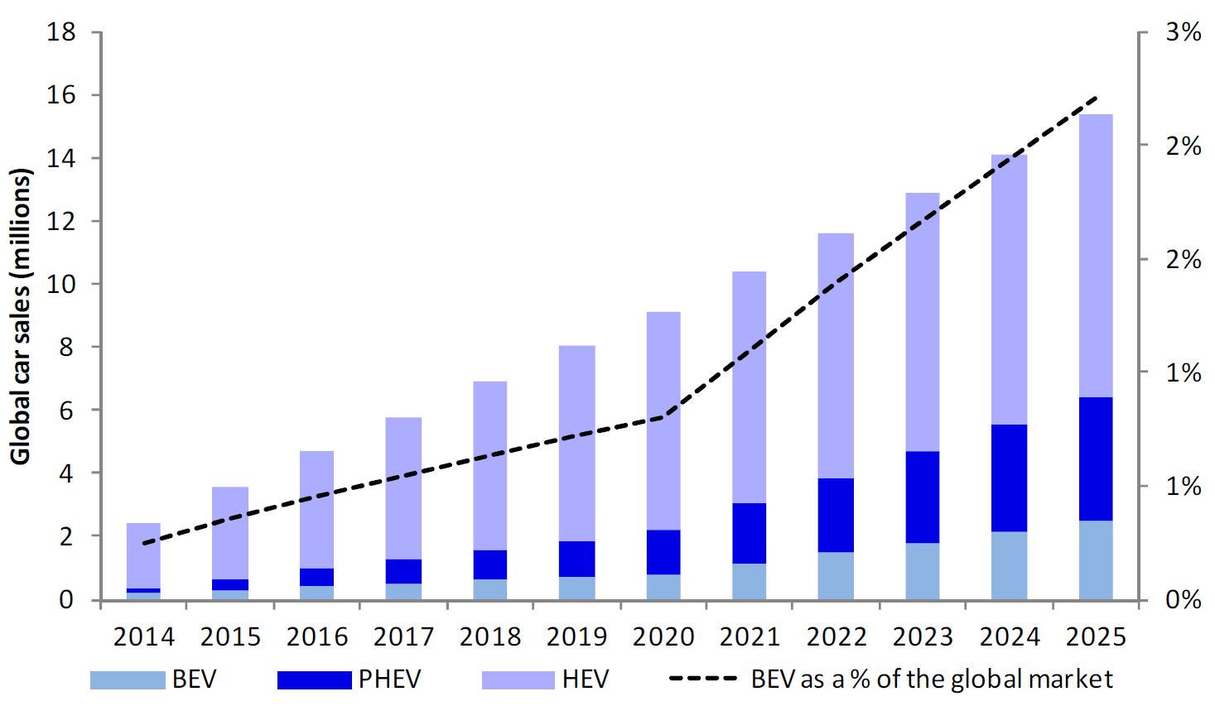

## Lithium-Ion Battery Chemistries

Lithium ion cells contain a positive and a negative electrode. The positive electrode (cathode) is made of various formulations or ‘chemistries’ of oxidized metals. The negative electrode is generally made of carbonaceous material (natural and synthetic graphite). When the battery is charged, ions of lithium move through an electrolyte from the cathode to the anode and attach to the carbon. During discharge, the lithium ions move back from the carbon anode to the cathode (See Figure 6).

The different battery types or ‘chemistries’ are defined by the compositions of their metalliferous cathodes. There are five main battery chemistries which comprise the majority of the LiB market. Of those, lithium-cobalt-oxide (**LCO**) is the dominant battery in portable electronic devices. The nickel-cobalt-manganese (**NCM**) and nickel-cobalt-aluminium (**NCA**) chemistries are increasingly becoming the industry standard for electric vehicle applications, due to their high energy density.

Rechargeable LiB Cell[3]

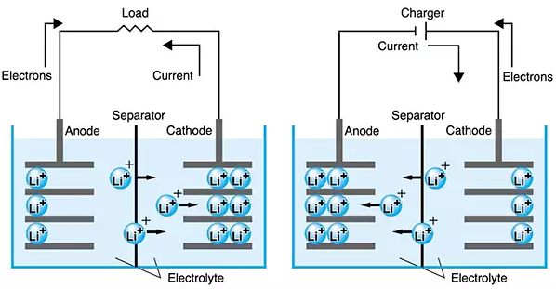

In recent years, China’s automotive industry has favoured adoption of lithium-iron-phosphate (**LFP**) and lithium-magnesium oxide (**LMO**) battery chemistries. However, there is a clear global trend to the adoption of NCM and NCA chemistry due to their higher energy densities, increased life cycle and the auto industry’s preference for passenger vehicles with longer range. Significant growth in the LiB sector is expected to come from NCM and NCA chemistries, both of which can contain relatively high nickel and cobalt content.

LiB Chemistry Market Share[4]

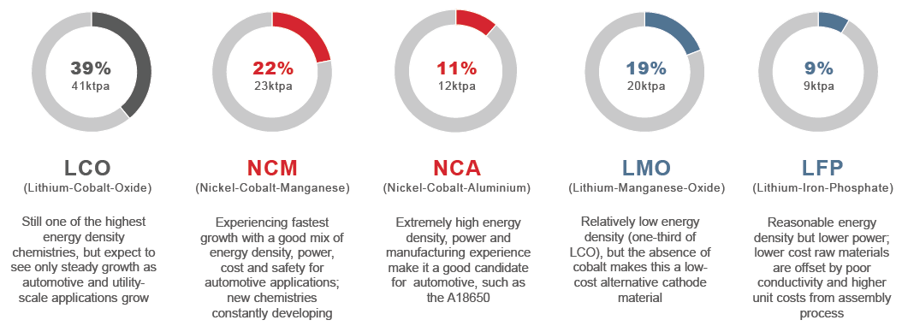

LiB cathode production requires high purity precursor materials to ensure high performance and extended battery life. NCA and NCM battery chemistries require high purity nickel sulphate (NiSO4.6H2O) and cobalt sulphate (CoSO4.7H2O) to produce precursor materials. LCO battery chemistry requires cobalt oxide.

## Cathode is Critical to Battery Cost and Performance

The cathode is fundamentally important to both the performance and cost-competitiveness of a lithium-ion cell. Raw materials can represent 50%–70% of the cost of manufacturing a lithium-ion cell, depending on the chemistry adopted. As such, nickel and cobalt can represent as much as 80% of the metal cost in the cathode, or approximately 20% of the total cell cost.

Estimated NCM Cell Cost Breakdown[5]

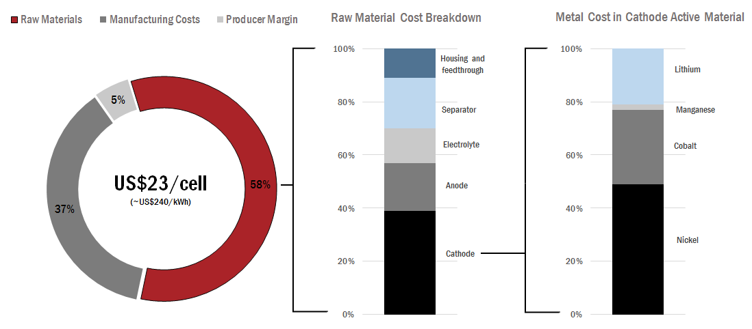

The predicted growth in the LiB market means that a considerable amount of high grade nickel sulphate and cobalt sulphate will be required over the next ten years. As such, reliable and cost-competitive nickel and cobalt supply has an important role to play in the future of LiB

LiB Cathode Raw Material Demand[6]

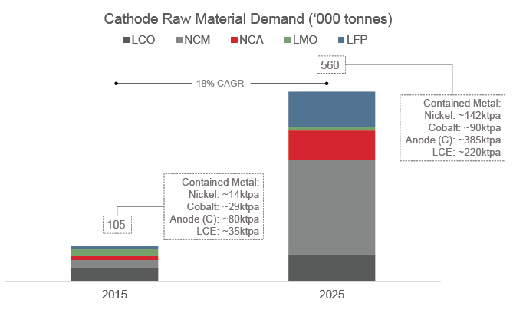

While there is a large and established market for nickel which is driven by the global steel sector, almost all the world’s cobalt is produced as a by-product from nickel and copper mines. For this reason, cobalt stands apart as one of the few metals consumed at industrial-scale that has almost no source of primary supply. Global refined production in 2015 was in the order of 90,000 tonnes[7] of contained cobalt, a large portion of which was exported to, and processed in, China. To meet the demands of the growing LiB market, there will need to be a significant increase in global supply of cobalt. At a time when nickel and copper prices are at or near long-term historic lows, this presents real challenges for cobalt supply, as seen in recent or pending mine and refinery closures in Africa (Katanga Mining) and Australia (QNI).

In addition to the risk through by-product dependence, global cobalt supply is heavily concentrated in the Democratic Republic of Congo (DRC). In 2015 production sources in the DRC represented 65% of global mined cobalt supply. A large portion of this production was from artisanal mining operations involving child labour.[8] While cobalt is not listed as a ‘conflict mineral’, the LiB industry is under increasing pressure to demonstrate an auditable cobalt supply chain to ensure that responsible procurement practices are adopted.

A recent report by Amnesty International and Afrewatch, “*This is what we die for: Human rights abuses in the Democratic Republic of the Congo power the global trade in cobalt”*, highlighted the child labour practices adopted in many of the artisanal mines and urged the global electronics and automotive industries to provide better auditing of their supply chains. See:

<http://www.amnesty.org.au/images/uploads/about/Amnesty_report_2016_Human_rights_abuses_in_DRC_power_global_cobalt_trade.pdf>

Syerston’s high cobalt grades, combined with Clean TeQ’s proprietary ion exchange technology to produce the specific cobalt and nickel sulphates required by lithium-ion cell manufacturers, positions the Company to benefit from strong forecast growth in demand for LiB’s.

1. *Source: Avicenne Energy Analysis 2014 et al as indicated. Avicenne estimates include China Auto Upside case.*
2. *Source: Deutsche Bank research 2016*
3. *Source: Stephen Evanczuk, DigiKey Electronics*
4. *Source: Avicenne Energy Analysis 2014*
5. *Source: Roland Berger (2012) and internal analysis. Assumes a 96Wh PHEV cell (26Ah, 3.7W) using NCM622 cathode chemistry. Cathode cost includes non-metallic materials (carbon black, binder, foil). Internal assumptions concerning split of costs assumes average long-term prices of Ni US$7.00/lb; Co US$12.00/lb; Mn US$1.00/lb; Li US$6.50/kg (as LCE).*
6. Source: Avicenne Energy Analysis 2014. 2025 case based on internal company estimates, utilising an EV adoption rate based on the average from five banks and industry consultant forecasts: HEV 5.7m, PHEV 2.7m, BEV 3.6m. EV applications forecast at 215 GWh. Non-EV applications forecast at 135GWh. Assumes an average battery size of 50kWh/BEV.
7. *Source: Darton Commodities, “Global Cobalt Review, 2015–2016”*
8. *Source: Darton Commodities, “Global Cobalt Review, 2015-2016”*